**Table Of Contents**

* Introduction
* Business Task
* Description of data source used
* Documentation of cleaning and manipulation of data
* A summary of my analysis
* Supporting visualizations and key findings
* Recommendations based on my analysis

**Introduction:**

This case study is from Google Data Analytics on Coursera. In this scenario, I am a junior Data Analyst working under marketing analyst team at Cyclistic, a fictional bike-share company in Chicago.

The company has two types of pricing, casual (single pass or day pass riders) and member (annual membership). The company’s future success depends on maximizing the number of annual memberships. Therefore, my task is to find out how the casual riders differ from member riders in using Cyclistic bikes. And based on my findings, I have my recommendations and conclusion on how the casual riders can buy the annual membership.

**Business Task:**

Design marketing strategies aimed at converting casual riders into annual members.

My task is to find out how annual members and casual riders use Cyclistic bikes differently.

**Description of data source used:**

Data source: [Index of bucket "divvy-tripdata"](https://divvy-tripdata.s3.amazonaws.com/index.html). The data that has been used for analysis is from January to April of 2021.

Licence: The data has been made available by Motivate International Inc. under the licence [Data License Agreement | Divvy Bikes](https://divvybikes.com/data-license-agreement).

**Documentation of cleaning of data: (Using Ms Excel)**

* Checked for duplicates and removed using ***remove duplicates*** under data tab.
* Trimmed each cell using ***TRIM*** function.
* Checked for typos and blank data using ***filter*** option.
* Found *length of each ride* by subtracting start station ride time from end station ride time.
* Found ride length in minutes using *HOUR, MINUTE and SECOND* formula.
* Found day of the week using *WEEKDAY* formula. And converted the numbers to actual days using ***find and replace***method.
* Found weekday and weekend using *find and replace* method.

**Documentation of manipulation of data: (Using Ms Excel)**

* Calculated the *mean and max* of ride length to check for any null or irrelevant data in cells.
* Calculate the mode of day of week
* Created ***pivot table*** to visualize the analysed data for each month using bar and line charts.

**A summary of my analysis: Key findings**

* The member riders use the bikes more in number than the casual riders. And the casual riders ride for longer period of time when compared to member riders per ride.
* The member riders ride more on weekday than on weekends. And casual riders ride more on weekends.

This tells us that the member riders might use it to commute to regular places such as their work place or school, etc. And casual riders use it to travel to random places with uncertainty.

* *The peak time is around 5 pm for both type of riders on the days. Also, for members, it is between 7 am and 8 am which tells us that they leave home around that time to start their commute for the day. And for casual riders, the start time is unpredictable.*
* Casual riders ride more in number around coastal regions for vacation purpose. Member riders are spread around evenly all around the state.
* Long time riders tend to use docked type bikes more. And casual riders use classic and electric bikes more.

**Supporting visualizations:**

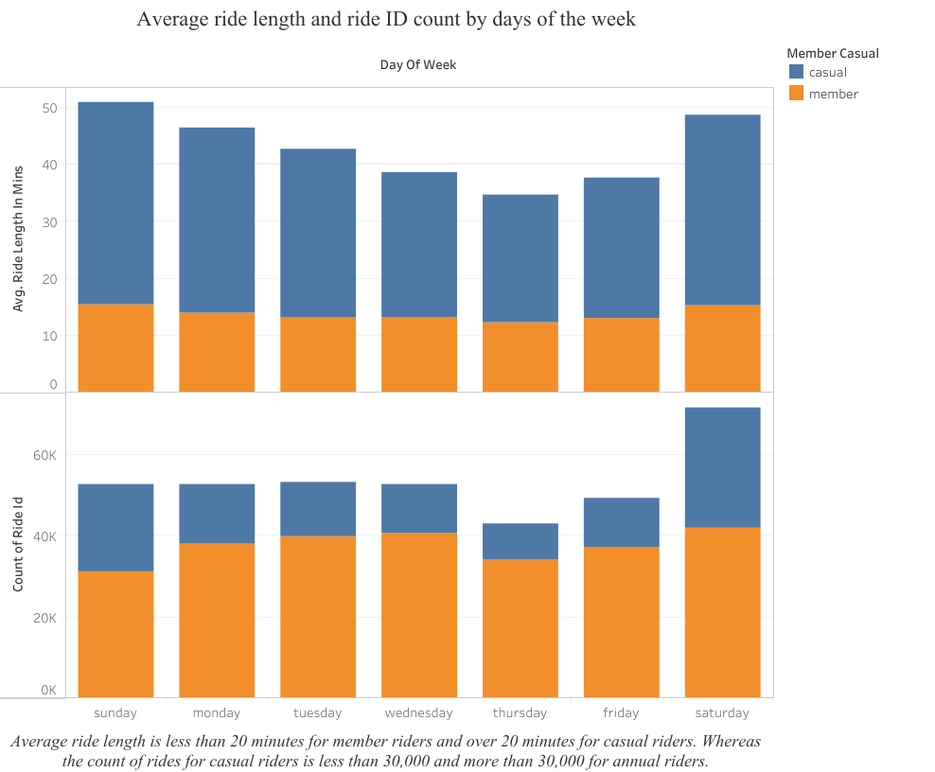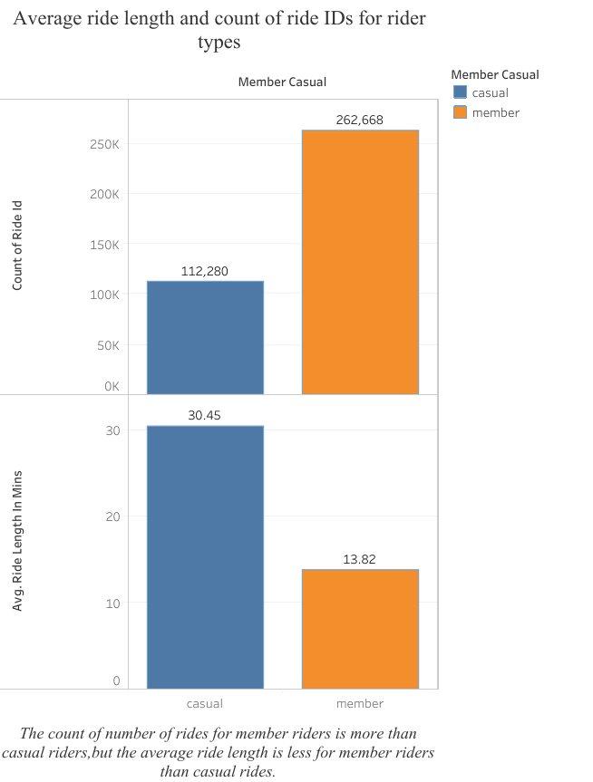

Figure 1 & 2: The count of ride length is more for member riders and less for casual riders. The average ride length is vice versa. This says that the member riders used Cyclistic bikes more number of times for daily routine and casual members used it for a long time for occasional purpose.

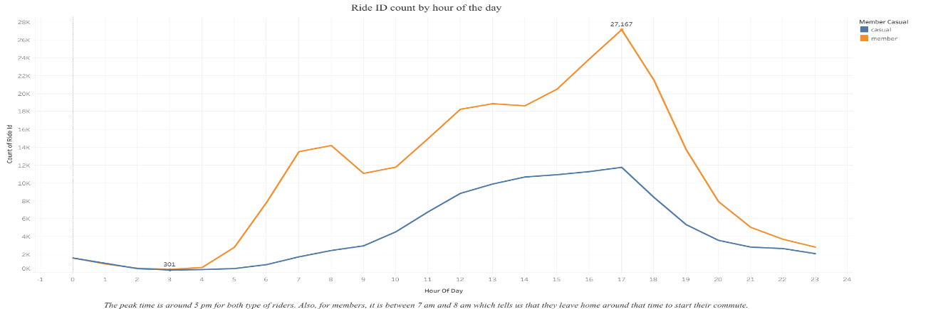

Figure 3: The peak time is around 5 pm for both type of riders. Also, for members, it is between 7 am and 8 am which tells us that they leave home around that time to start their commute.

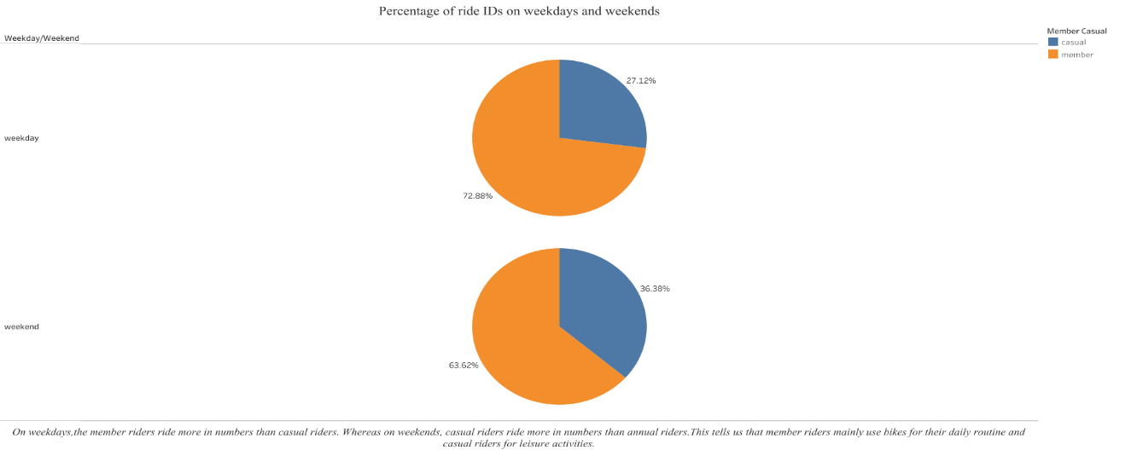

Figure 4: On weekdays, the member riders ride more in numbers than casual riders. Whereas on weekends, casual riders ride more in numbers than annual riders.

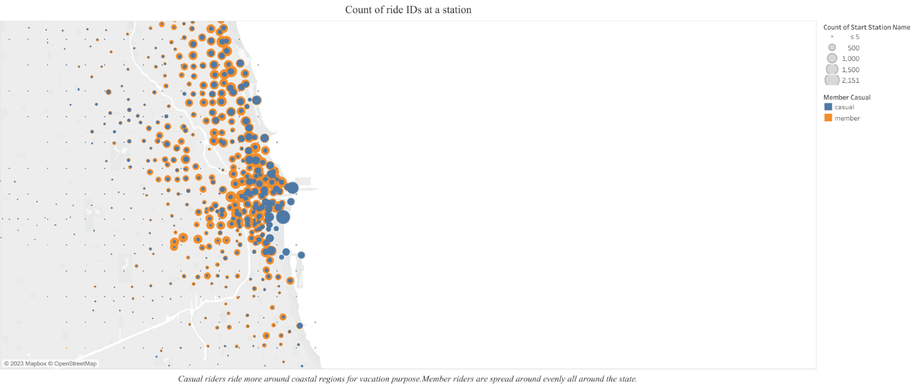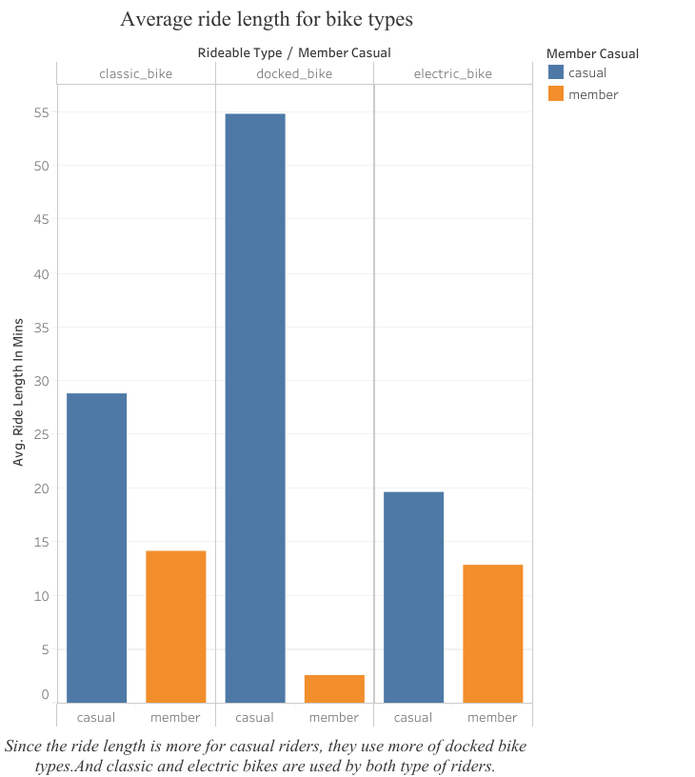

Figure 7: Casual riders ride more around coastal regions for vacation purpose. Member riders are spread around evenly all around the state.

Figure 6: Since the ride length is more for casual riders, they use more of docked bike types. And classic and electric bikes are used by both type of riders.

**Recommendations based on my analysis:**

* Casual riders ride more on weekends. So, the company can give them two options: one is to offer weekend passes for high price. Second is to offer annual membership with extra benefits. The extra benefits must include unlimited riding time on weekends and less price on annual subscription when compared to weekly subscription. They can also introduce a monthly subscription at the beginning to attract the casual riders with offers similar to annual membership.
* Priority must first be given to member riders. The Cyclistic bike share company must open an app or a software and allow for membership riders only to book for the type of bike they want to use beforehand. This not only encourages casual riders to opt for annual membership but also retains the member riders in the company for a long period.
* If the area is around coastal regions, the prices can be increased because due to the humidity and salt content near coastal regions, the bicycles tend to lose its efficiency, gets rusted soon and more service needs to be done. And based on my data analysis, the casual riders ride more near coastal region. Therefore, increase in price is a must near those areas.
* If there is a competition in the market, it becomes important for Cyclistic to consider all the recommendations.
* Since the data does not provide personal information about casual riders, more data is required to know about the proportion of casual riders whether they are local residents or visitors from outside town in order to customize membership program. It is also important to consider how flexible casual riders are in terms of price variation.